**Draft Analysis**

**Recording Conditions and Electrode Placement**

The EEG was connected to a battery-powered laptop in a room without any plugged-in appliances or electronic devices that could emit electrical frequencies. The subject used an OpenBCI Cyton board with 8 electrodes and conductive gel. One electrode served as reference and another as bias, both connected to the mastoid area. The other six electrodes were symmetrically placed on both sides of the head: F1, F2, FT7, FT8, T7, and T8. These positions were chosen because of better scalp contact, as the subject had shorter hair in those areas. The electrode contact areas were cleaned with alcohol to remove natural skin oils and dead skin cells.

**Electrode Positions:**

* **F1, F2:** Attention, decision-making, emotional processing.
* **FT7, FT8:** Emotional and cognitive information, auditory processing.
* **T7, T8:** Responses to auditory stimuli.

A total of 104 20-second samples were recorded using this configuration.

Electrode contact quality was critical. Sessions were limited to under one hour to prevent conductive gel oxidation and participant fatigue. Electrode areas were cleaned with alcohol, and a swim cap was used to tighten electrodes to the scalp, reducing impedance from hundreds of kΩ to under 45 kΩ.

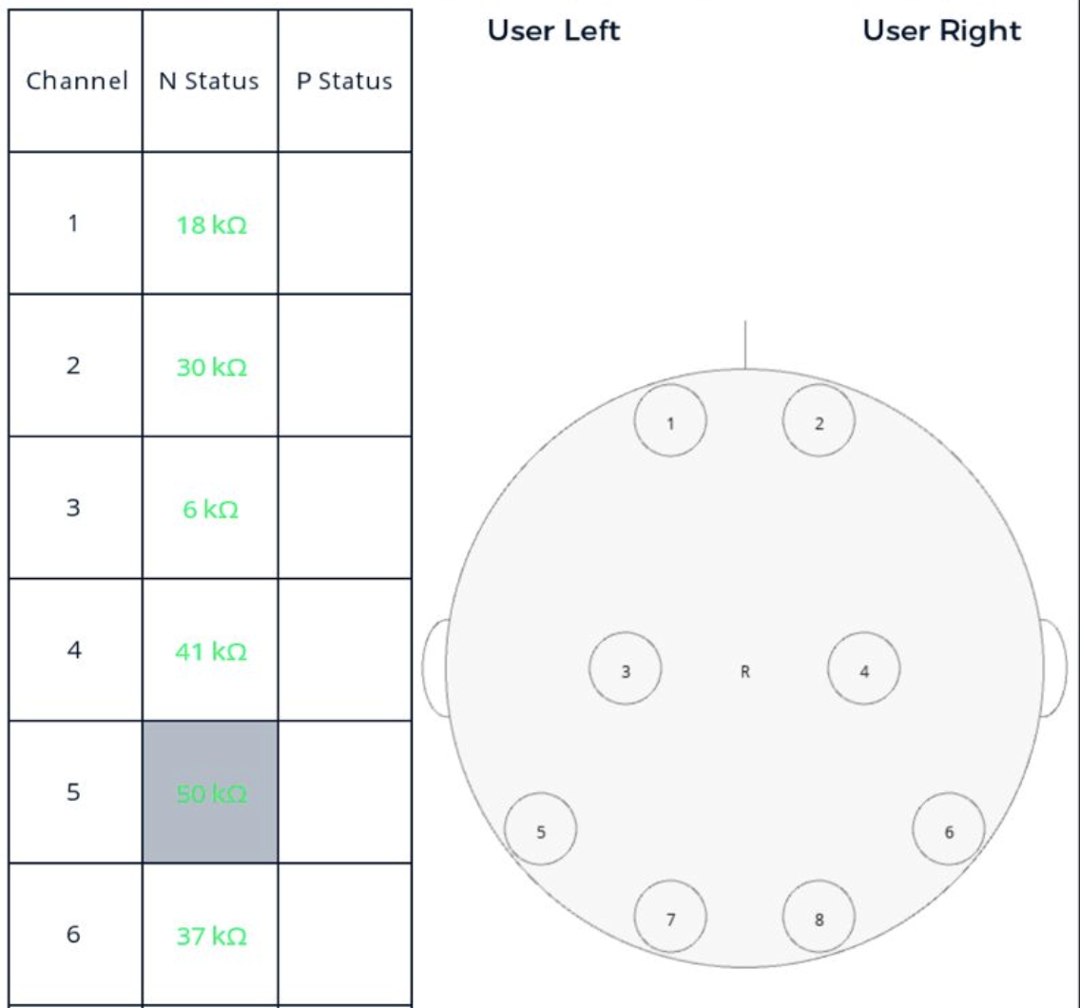

**Figure 0:** Impedance measurement tool in OpenBCI GUI.

High impedance prevents clean signals from reaching the amplifier, amplifying noise instead. Maintaining low impedance is essential.

**Recording Method**

An automated script plays 20-second segments of songs from two playlists ("liked" and "disliked") and records EEG during playback. These tracks were chosen for their strong emotional response in the subject. The recording starts at second 6 and ends at second 26 to allow time for command transmission via BrainFlow and to give the brain time to adjust to the stimulus. The subject kept their eyes closed and remained still to minimize noise.

**Preprocessing Steps**

EEG data was acquired using BrainFlow. A 1Hz high-pass filter was applied to remove drift, and a 50Hz notch filter eliminated electrical noise. The first 2.5 seconds of each trial were removed due to initial noise caused by dongle connection and command delay.

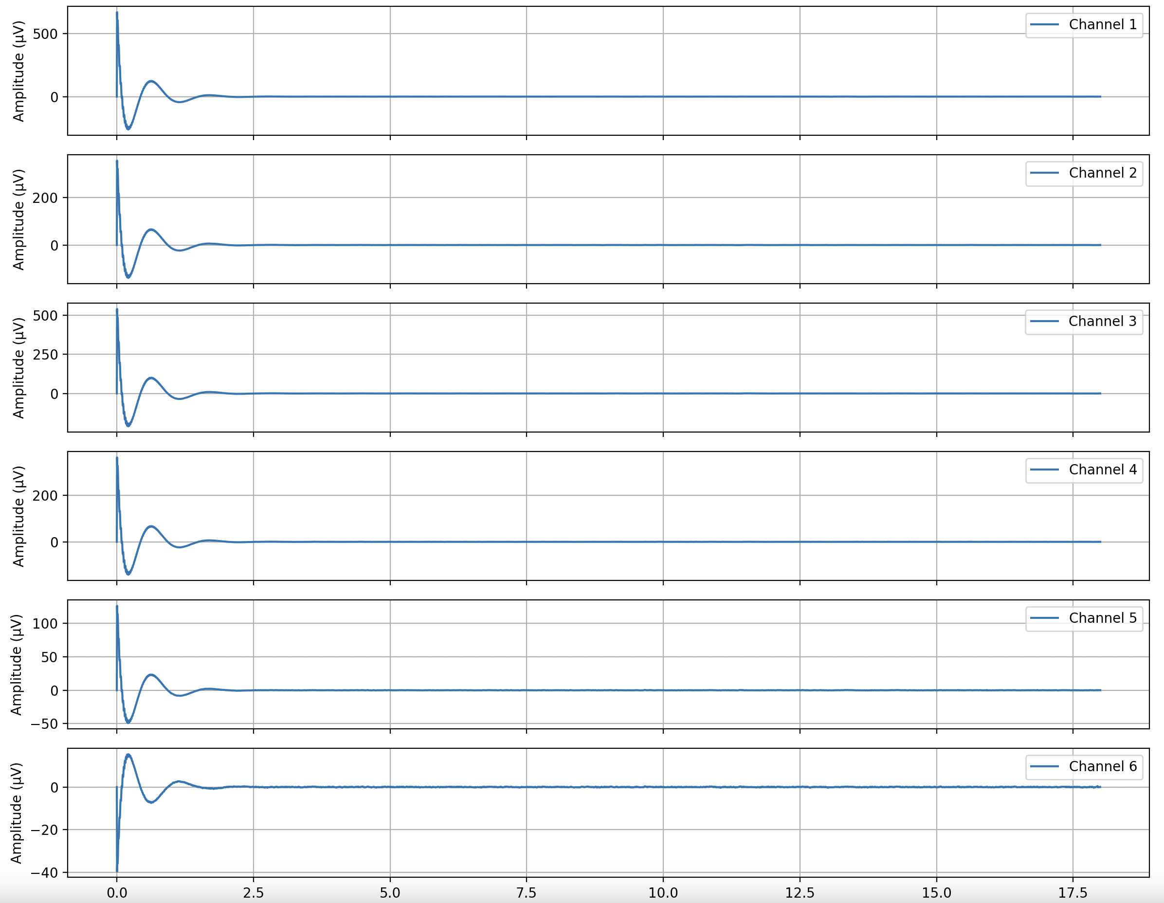

**Figure 1:** Time-domain plot after high-pass and notch filtering.

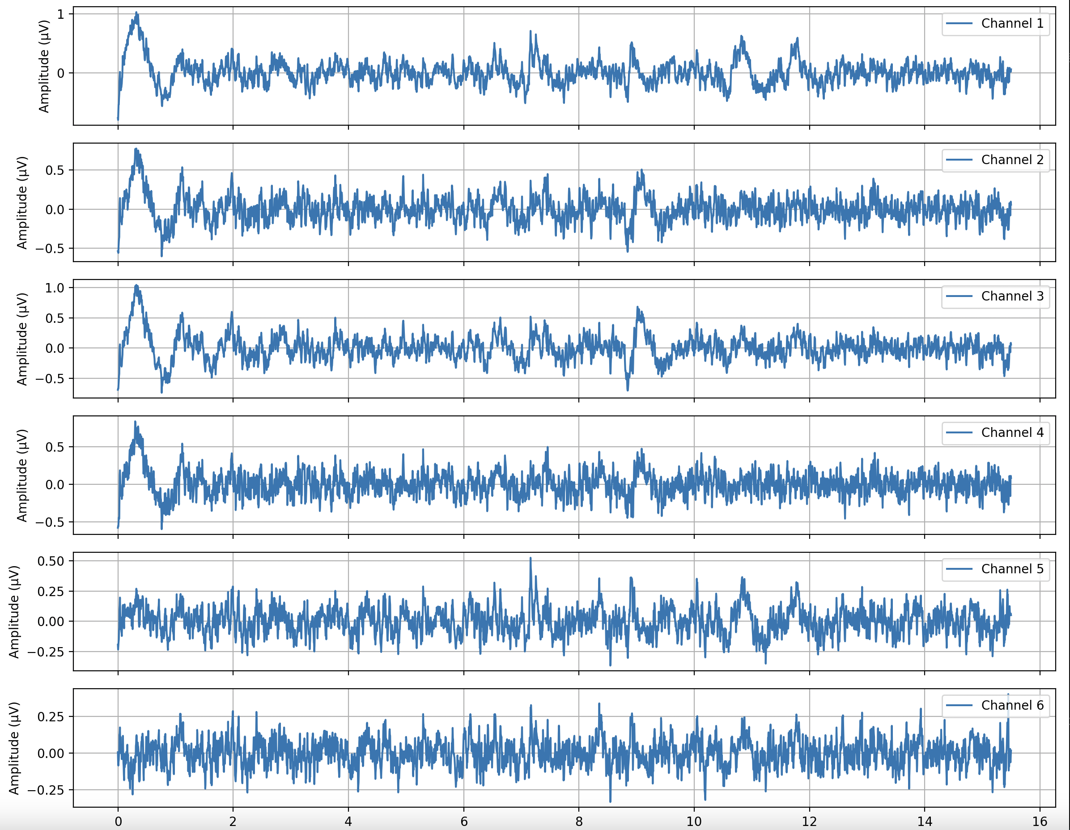

**Figure 2:** Time-domain plot after cutting first 2.5 seconds.

A Butterworth bandpass filter (4–40 Hz) was applied to remove low-frequency noise.

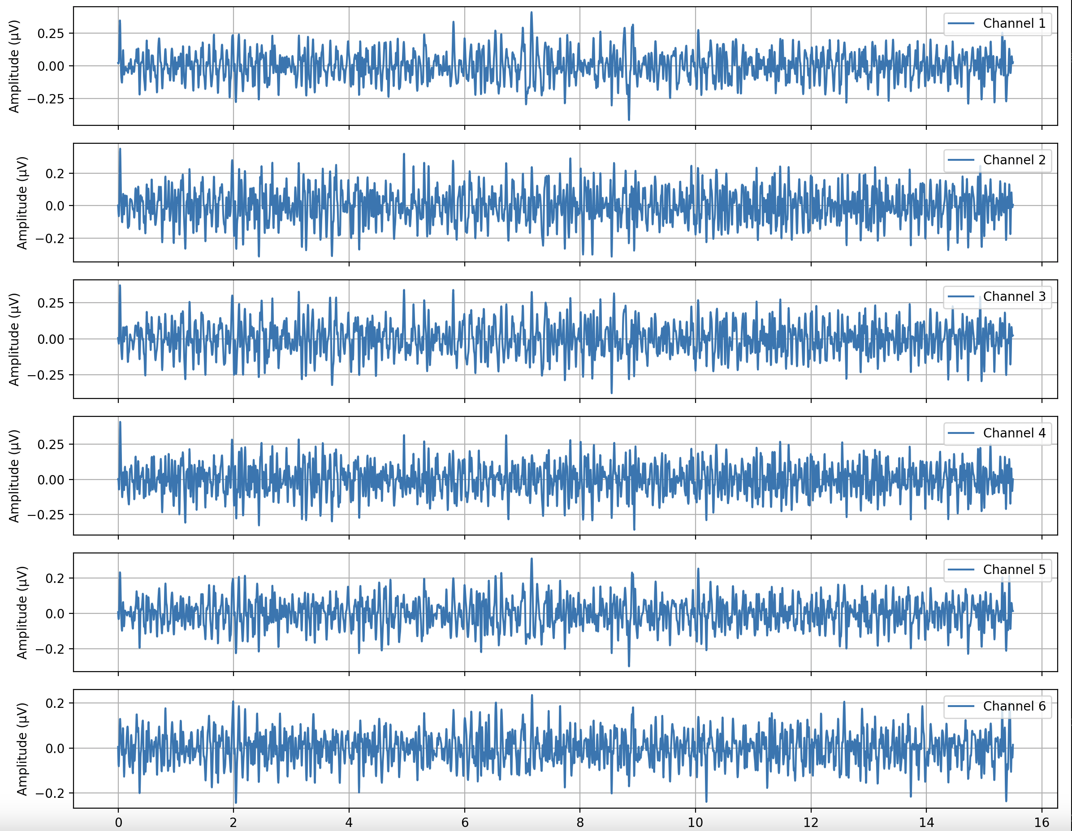

**Figure 3:** Time-domain signal after bandpass filtering.

Power Spectral Density (PSD) was plotted using the Welch method to detect spikes and observe power in specific frequency bands.

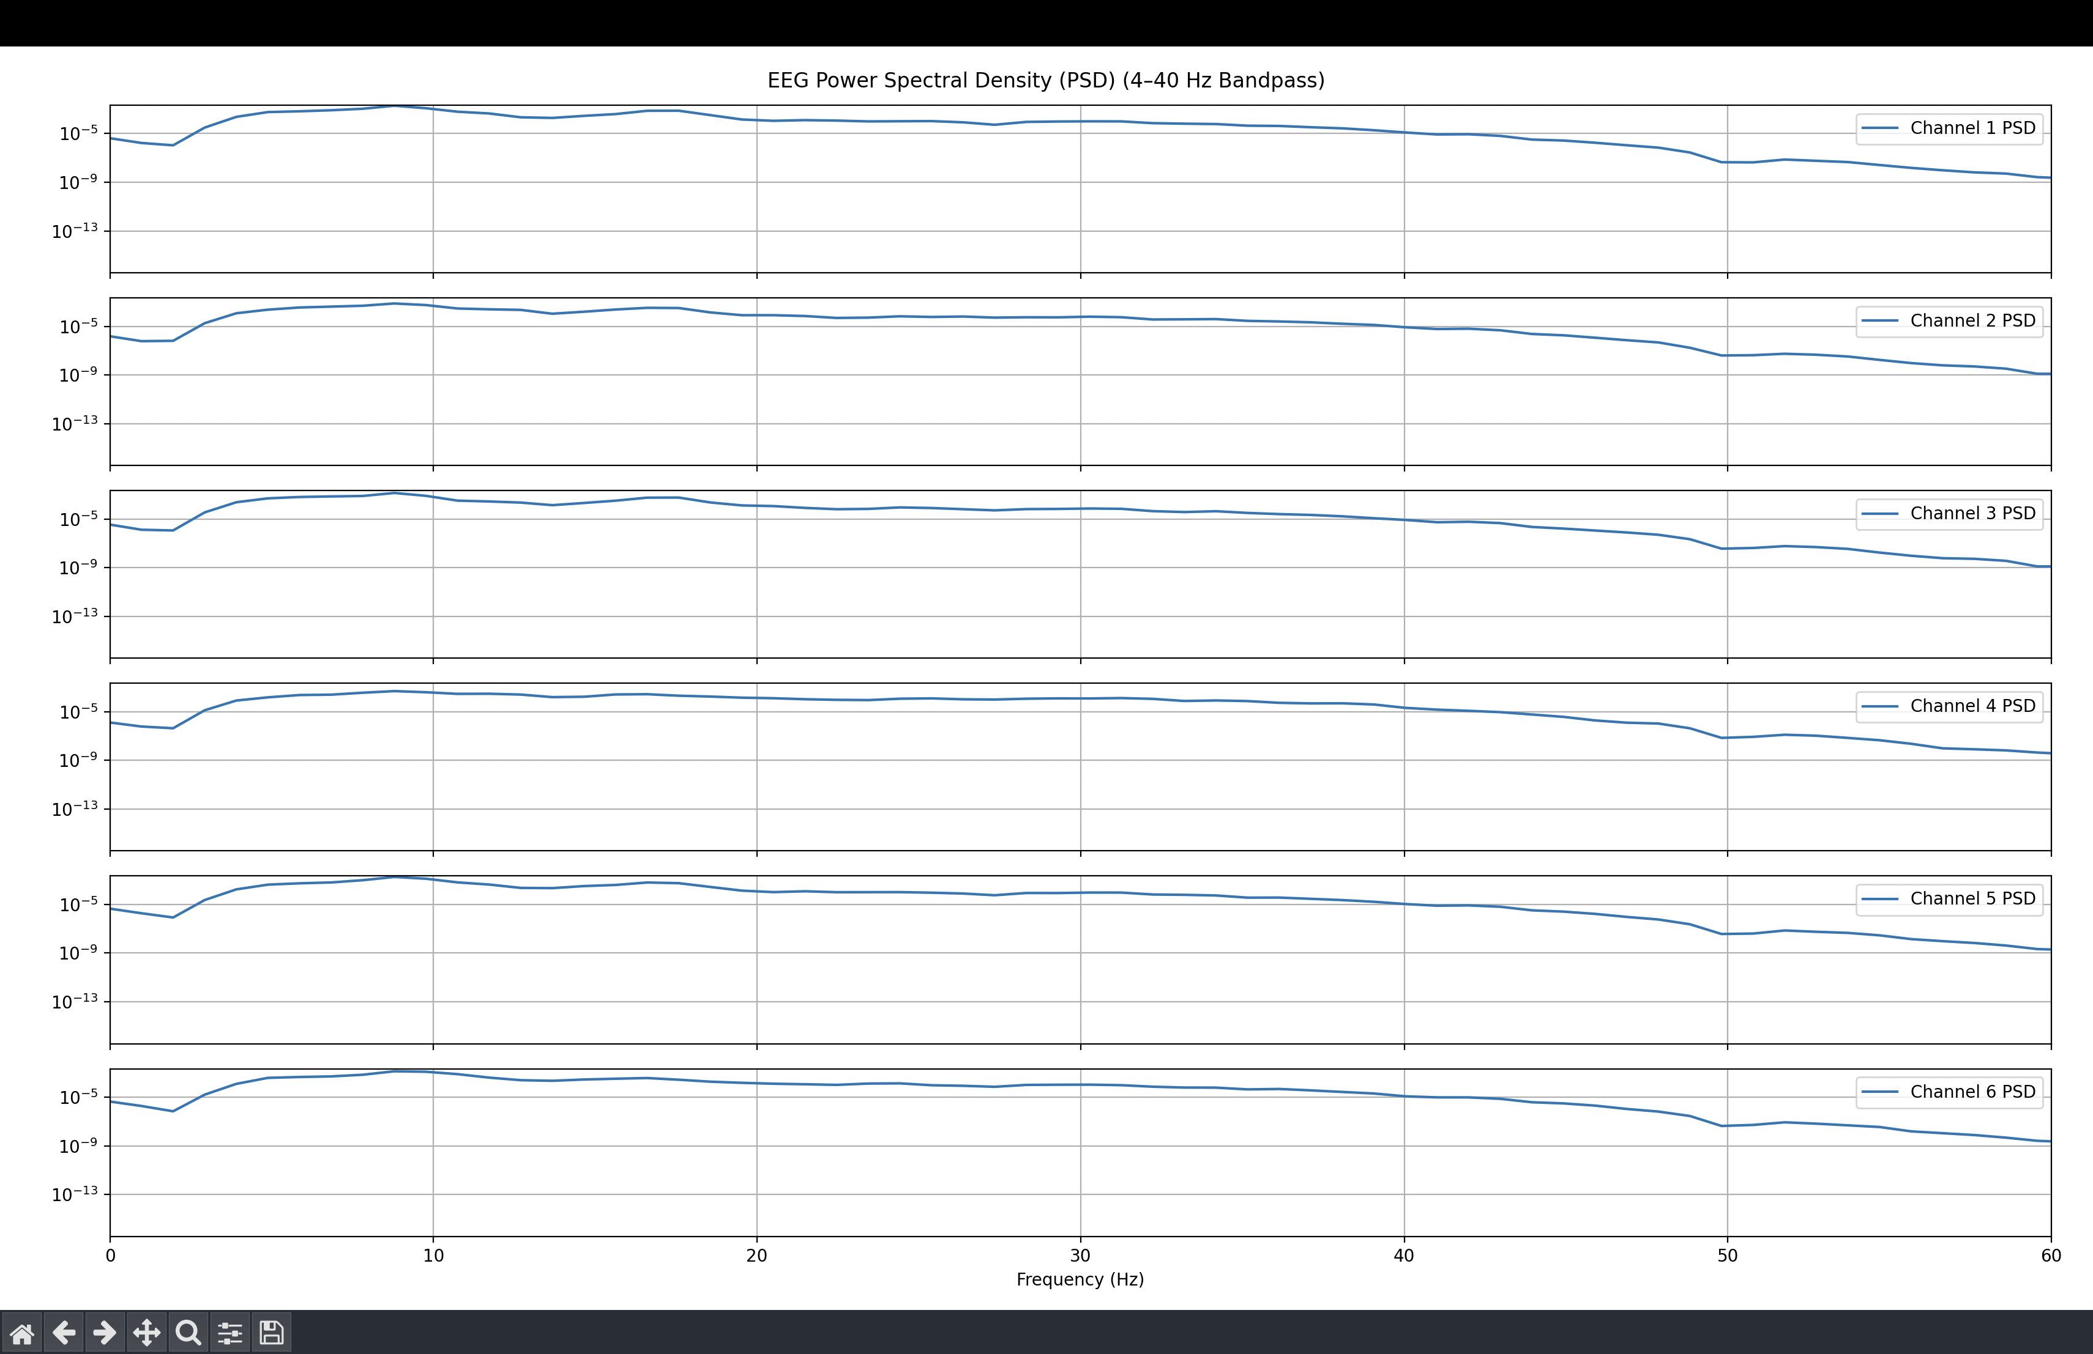

**Figure 4:** PSD via Welch method.

Wavelet denoising was used instead of ICA, as only 6 channels were recorded. ICA is generally recommended for setups with at least 8 channels. Wavelet denoising decomposes the signal into coefficients, estimates a threshold, and removes noise while preserving important signal details. The signal is then reconstructed using the inverse wavelet transform.

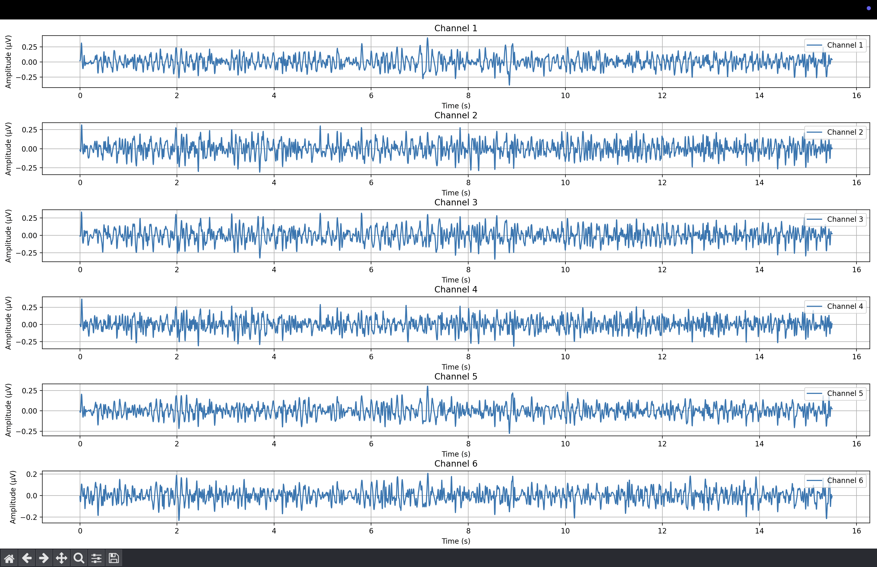

**Figures 5 :** Time-domain plots after Wavelet denoising.

**Feature Extraction**

Data was collected from one subject using two electrode configurations. The section below refers to the frontal and temporal lobe configuration.

The primary feature was Power Spectral Density (PSD) for theta, alpha, and beta bands.

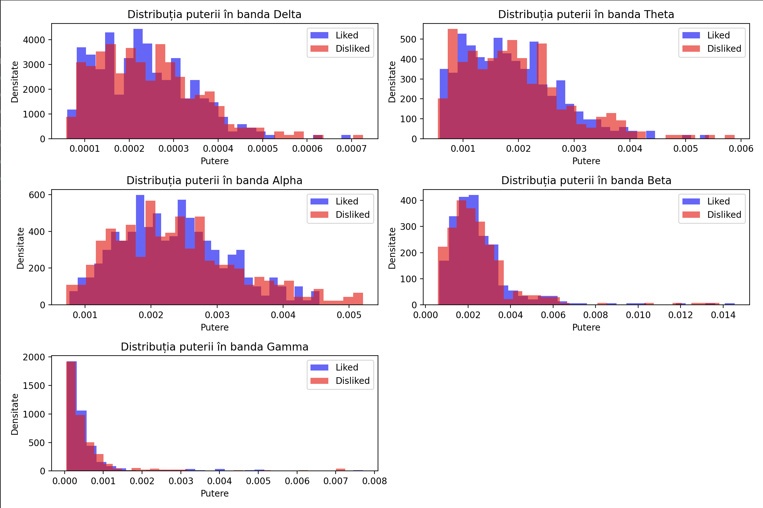

**Figure 6:** Power distribution per frequency band.

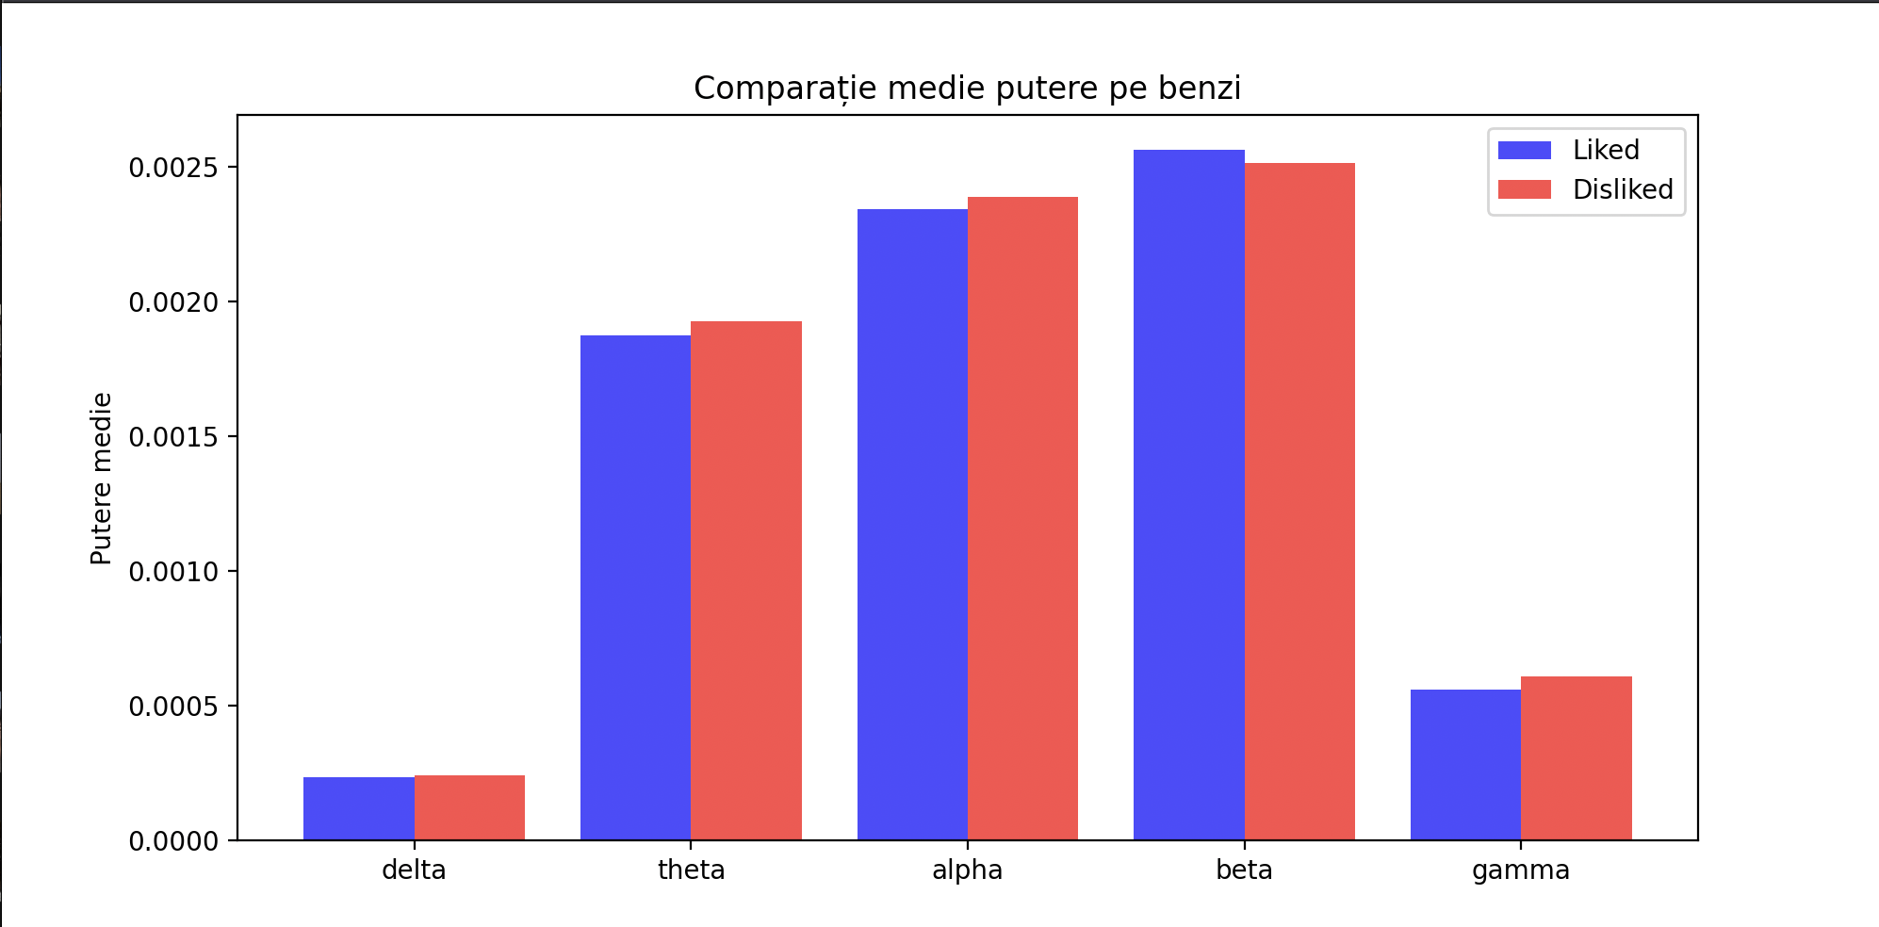

**Figure 7:** Mean power per band.

Delta and gamma bands were excluded due to high noise. Delta is related to deep relaxation and sleep, while gamma is linked to high-level cognition.

Hjorth parameters were used:

* **Activity:** Measures signal variance.
* **Mobility:** Indicates how quickly the signal changes.
* **Complexity:** Measures the ratio of second to first derivative mobility.

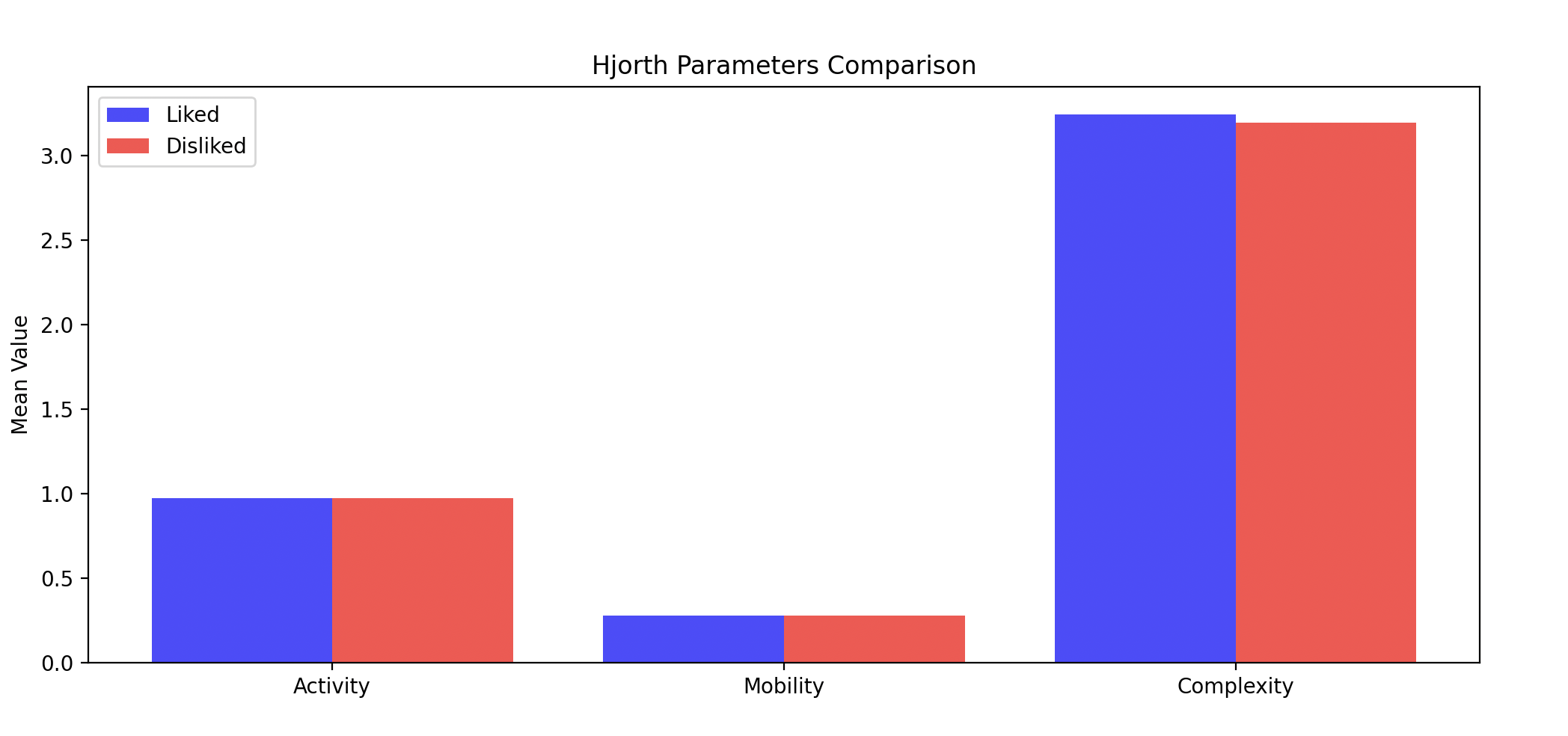

**Figure 8:** Hjorth parameters.

Other features:

* **Shannon Entropy:** Indicates signal unpredictability.
* **Zero Crossing Rate (ZCR):** Reflects how often the signal crosses zero.
* **Spectral Entropy:** Shannon entropy applied to normalized PSD.

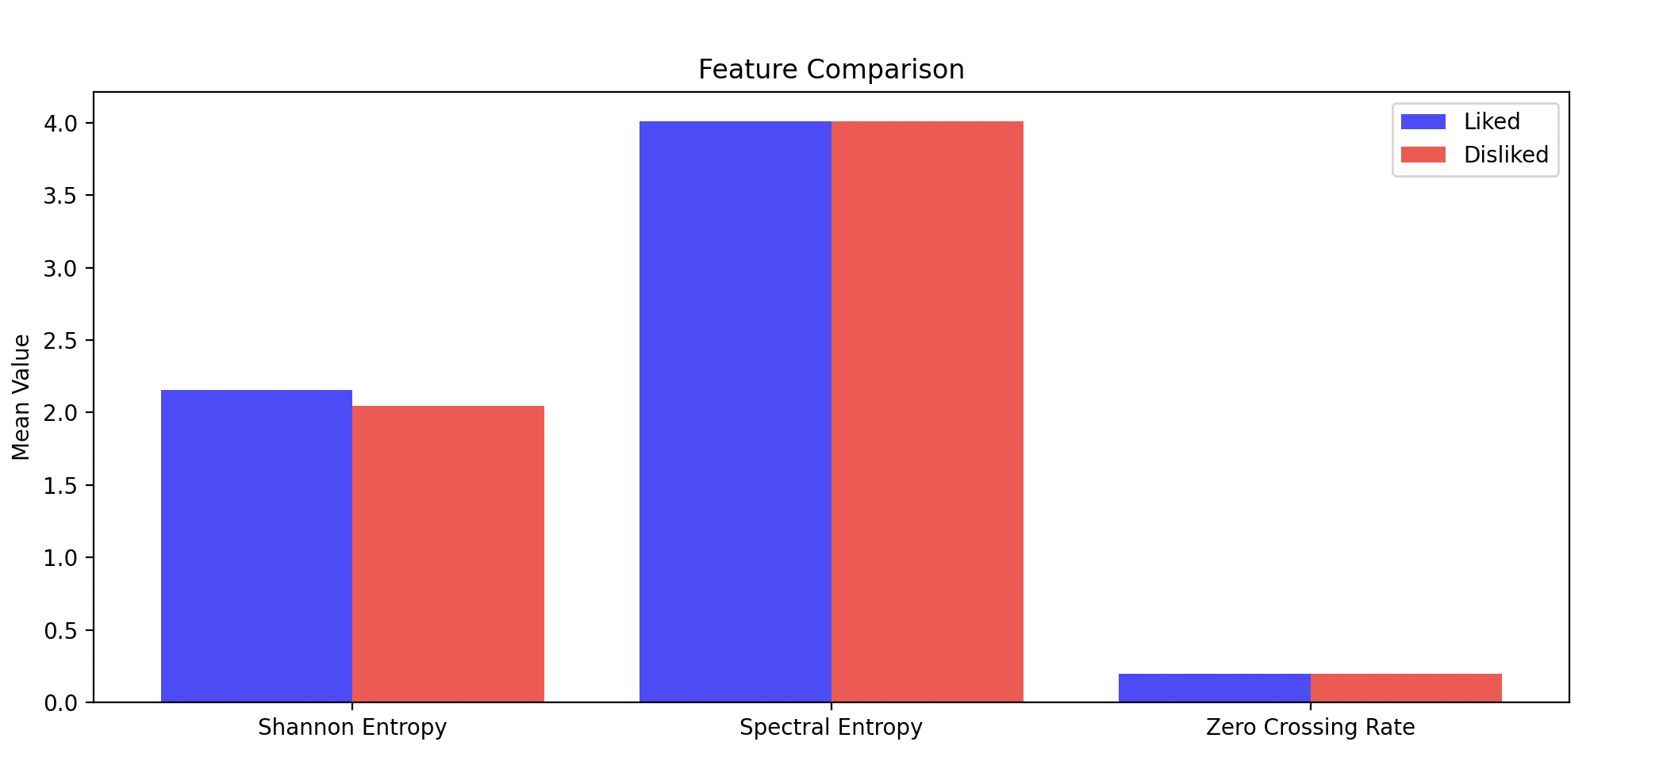

**Figure 9:** Entropy and ZCR plots.

Additional features:

* **Wavelet Coefficients:** Show frequency components in time windows (e.g., theta during relaxation).
* **PLV (Phase Locking Value):** Measures synchronization across brain regions using Hilbert transform.
* **Fractal Dimension:** Reflects signal complexity and brain region activity.

**Wavelet Denoising Impact on Model Accuracy**

Wavelet denoising can sometimes remove important signal information. Therefore, six basic models were tested on a dataset of 100 samples (50 per class):

* SVM (linear kernel, C=0.05)
* Random Forest (2 trees, max depth=2)
* KNN (3 neighbors)
* XGBoost (20 estimators, max depth=2, learning rate=0.1)

Gradient Boost and Neural Networks were excluded due to small dataset size.

5-fold cross-validation was used. Features: mean, variance, PSD per channel.

|  |  |  |
| --- | --- | --- |
| **Model** | **Without Wavelet Denoise** | **With Wavelet Denoise** |
| SVM | 0.55 (0.07) | 0.57 (0.01) |
| Random Forest | 0.59 (0.16) | 0.53 (0.31) |
| KNN | 0.50 (0.20) | 0.54 (0.16) |
| XGBoost | 0.45 (0.43) | 0.59 (0.37) |

Conclusion: Wavelet denoising is beneficial overall, especially for SVM and XGBoost, improving accuracy and reducing overfitting.

**SNR Evaluation and New Electrode Setup**

SNR was initially low or even negative, calculated as the ratio between trial signal and baseline (recorded in similar conditions without stimulation).

A new configuration was tested:

* 8 electrodes: Fp1, Fp2, F1, F2, T7, T8, plus 2 parietal electrodes near P3 and P4.
* 15-second rest between stimuli.
* 20-second recording per trial.
* Music was diversified.
* Screen time reduced to prevent fatigue.
* 100 new samples were recorded.
* Data was not scaled.
* 1Hz high-pass + 50Hz notch filter applied.
* First 2.5 seconds trimmed due to dongle noise.

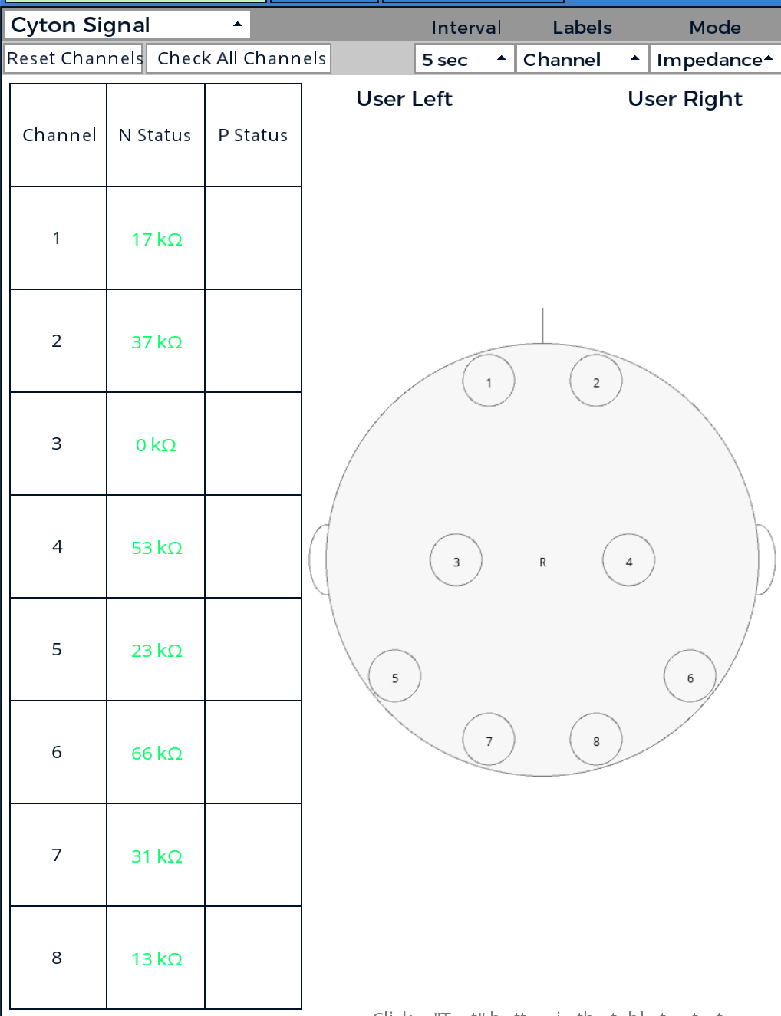

**Figure 12:** Impedance (channel 3 ~25 kΩ).

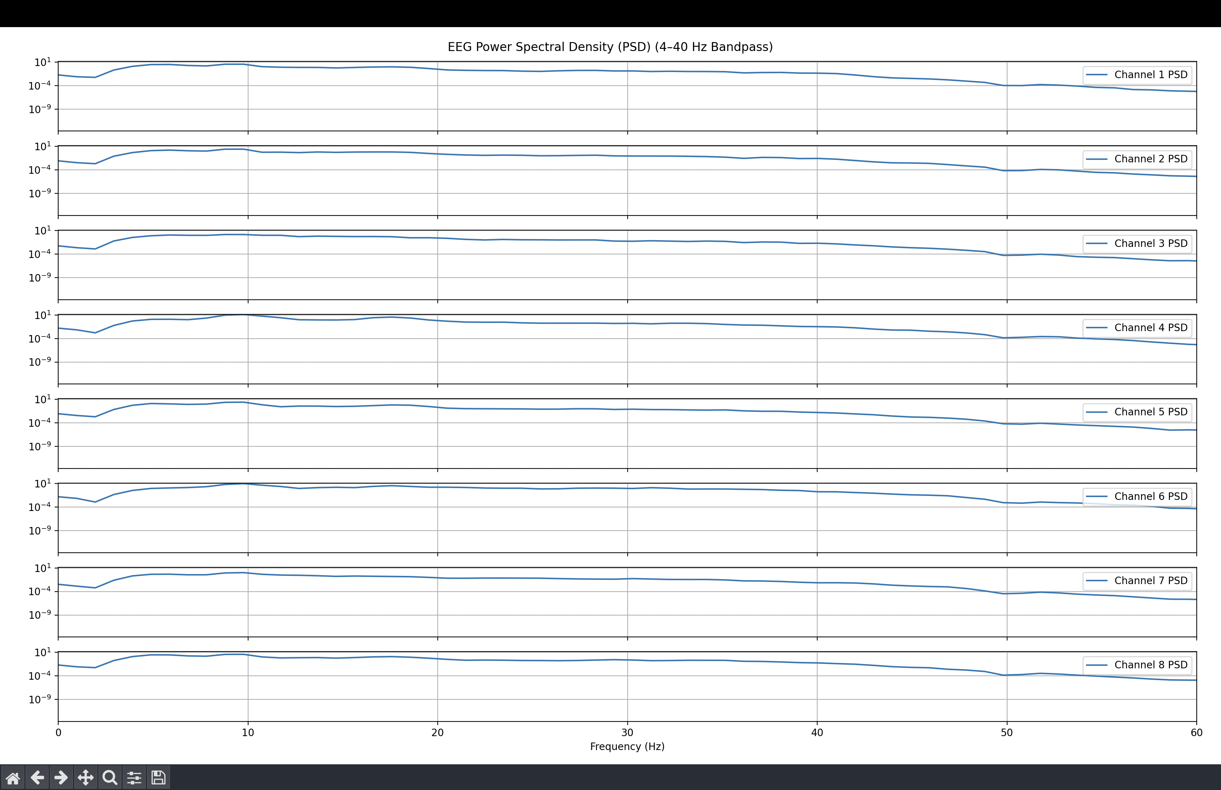

**Figure 13:** PSD - new configuration.

**Figure 14:** Time Domain - new configuration.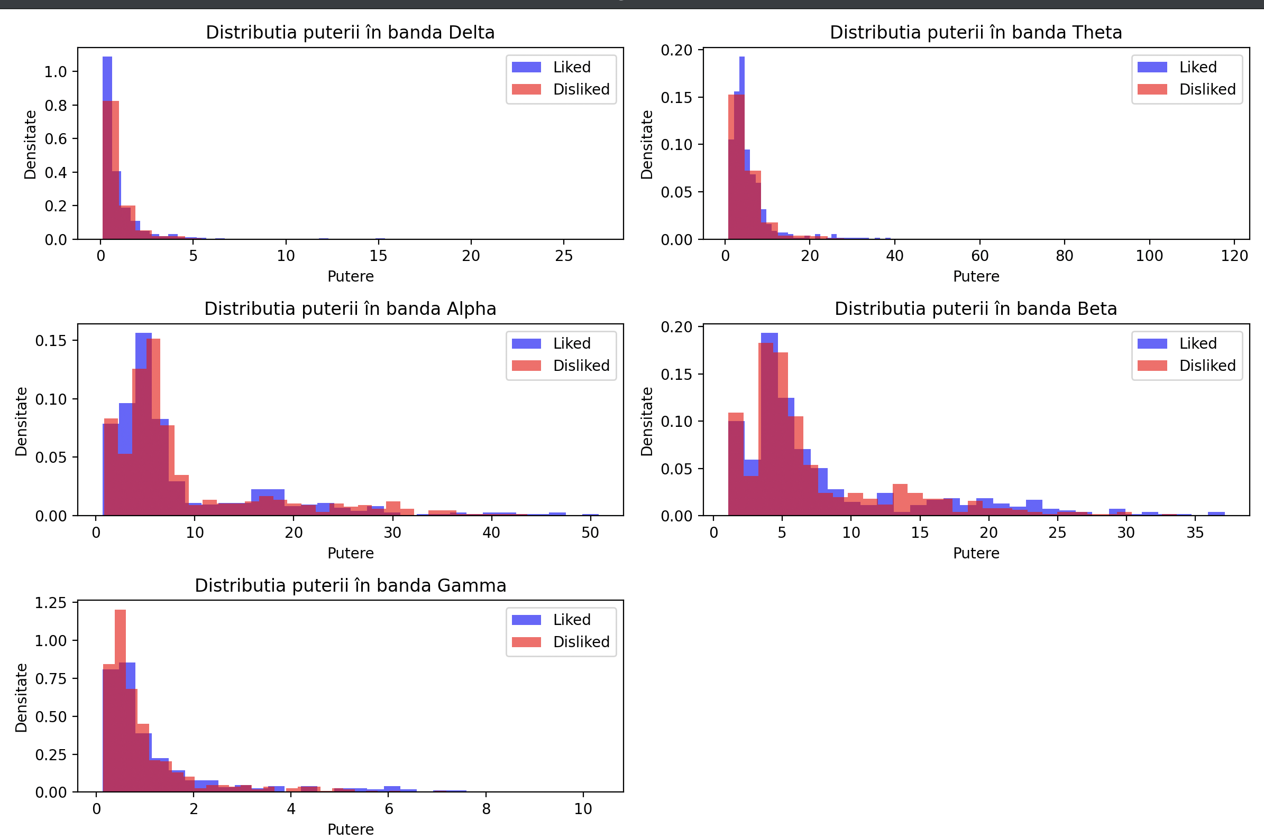

**Figure 15:** PSD distribution.

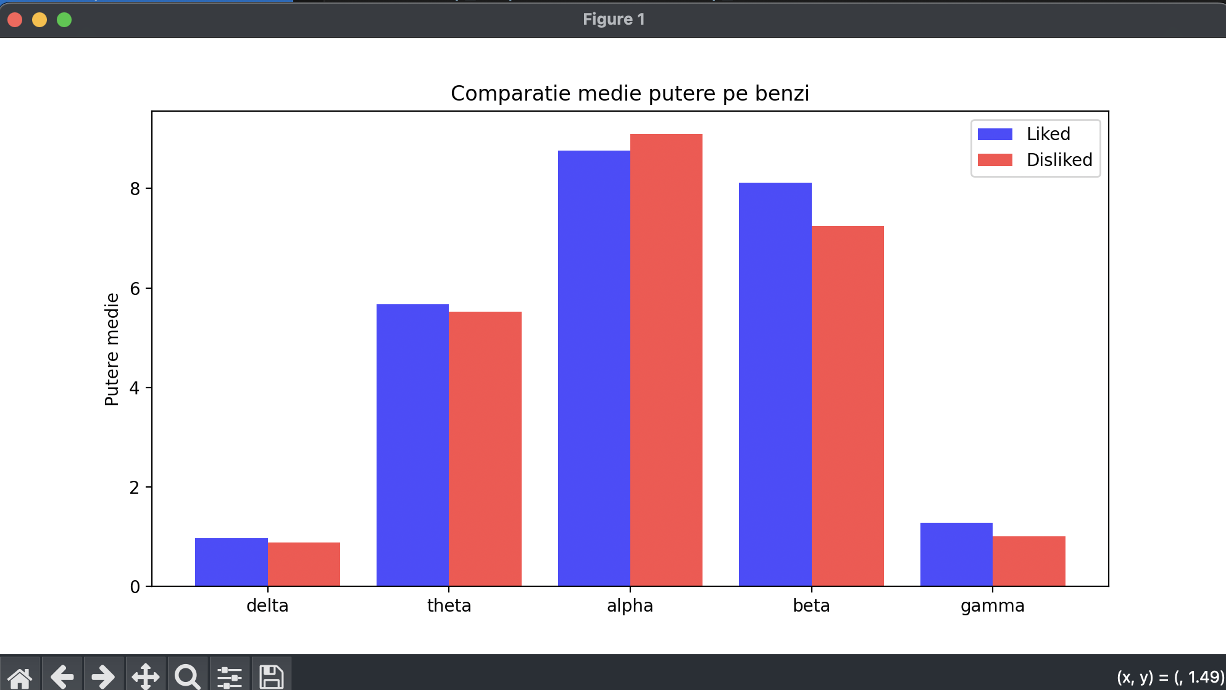

**Figure 16:** Welch method PSD.

Figure 16 shows clearer differences in theta, alpha, and beta bands between liked and disliked states.

Using the same simple models:

|  |  |  |
| --- | --- | --- |
| Model | Without Wavelet Denoise | With Wavelet Denoise |
| SVM | 0.72 (0.06) | 0.72 (0.01) |
| Random Forest | 0.68 (0.10) | 0.57 (0.24) |
| KNN | 0.61 (0.20) | 0.54 (0.16) |
| XGBoost | 0.69 (0.25) | 0.63 (0.29) |

Conclusion: SVM again benefits most from Wavelet denoising. New electrode placement led to better signal clarity and model performance.

**Latest Results and Deep Learning Potential**

As of now, over **600 trials** have been recorded using the subject's dataset. The best result so far is achieved using **K-Nearest Neighbors (KNN)** with a **test accuracy of 65%**, outperforming other classical models:

SVM => Train Acc: 0.63, Test Acc: 0.60, Overfit Gap: 0.03, Kappa: 0.20

RANDOM_FOREST => Train Acc: 0.76, Test Acc: 0.64, Overfit Gap: 0.13, Kappa: 0.27

KNN => Train Acc: 0.72, Test Acc: 0.65, Overfit Gap: 0.07, Kappa: 0.30

XGBOOST => Train Acc: 0.68, Test Acc: 0.64, Overfit Gap: 0.04, Kappa: 0.28

MLP => Train Acc: 0.70, Test Acc: 0.62, Overfit Gap: 0.08, Kappa: 0.24

These results were obtained using **RFE (Recursive Feature Elimination)** and **PCA (95% explained variance)**, along with **Stratified K-Fold cross-validation**.

A more advanced Transformer-based deep learning model was also tested, with promising results:

5-Fold CV Results (Transformer):

Mean Test Accuracy: 0.6858 ± 0.0925

Mean Train Accuracy: 0.7272 ± 0.1028

Although classical models perform reasonably well, early testing suggests that **deep learning may be the key to significantly improving accuracy**, especially as more data is collected and used in training. This makes the Transformer model a promising direction for future research and development.